**Day 12: 05 Oct. 25**

Testing: Testing is use to find the defect or error or bugs in the application.

Running the program or code without main file or main function or main methods.

Types of testing

1. Black box testing:

Input Process Output

1. White box testing:

Input Process Output

Unit testing : Unit testing is a type of white box testing which help to test function functionality working or not base upon client requirement. Unit means smallest cod which work independently. That code generally we write inside function or method etc

Java 🡪Junit

.net 🡪 nunit

JavaScript :

1. Jasmine
2. JEST
3. Mocha

Plain JavaScript (Client side JS) we use Jasmine etc.

React JS with we use JEST.

Node JS we can use Jasmine as well as Mocha

Angular framework with Jasmine with Karma testing tool.

Mocha: Mocha is an Open Source testing framework that run on Node js (Server Side scripting) as well as using browser(client side scripting) etc.

1. Simple testing using mocha testing framework.

Create the folder with name as simple-testing-with-mocha

npm init -y

npm install mocha -D

or

npm install mocha --save-dev

in package inside script body you need write

**“test”:”mocha”**

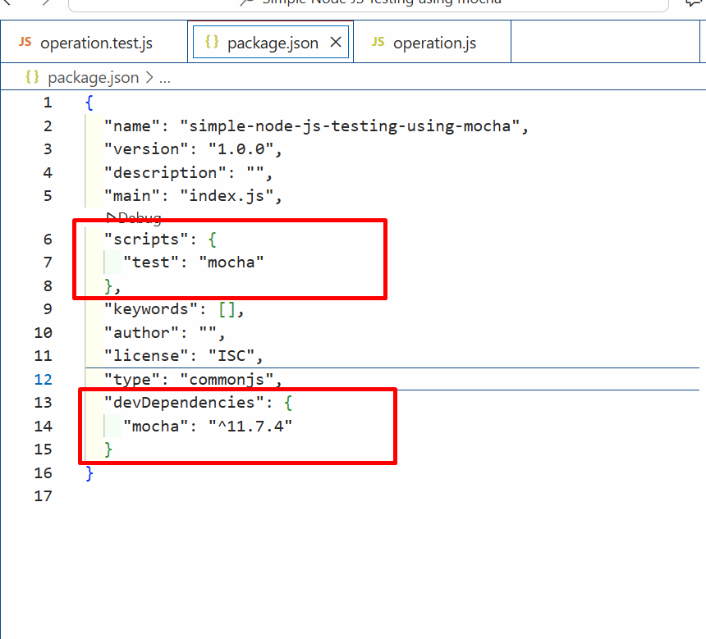

test suite : test suite contains more than one test function which we can write using test() or it(). To write the test suite all testing framework provided describe() function

test case : test case is a type of function which help to test individual test functionality working or not. To write test function we need to use it() or test().

describe(“Suite Name”,callback)

it(“testing function name”,callback);

to run the testing file you need to run the below command as

npm test

**testing rest api using mocha testing framework**

creating folder with name as **product-rest-api-test**

**npm init -y**

**npm isntall express**

**npm install mocha -D it provide as describe and it function**

**npm install chai -D it provide more assert functions.**

**npm install chai-http -D** it help to test rest api or http protocol test

inside package.json file please write “test” :”mocha”

,

  "scripts": {

    "test": "mocha"

  },

Phase end project

mkdir stock-api-project

cd stock-api-project

npm init -y package.json file

npm install express axios mongodb/mongoose

like example

mkdir consume-product-rest-api

cd consume-product-rest-api

npm install express axios